WEBSITE CONTENT
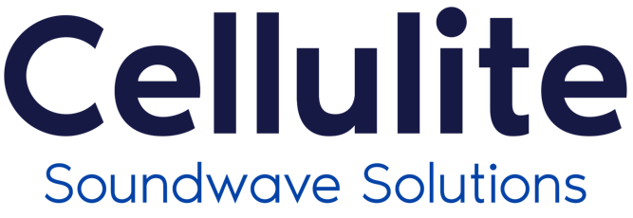

IMPROVE THE APPEARANCE OF YOUR SKIN WITH SOUNDWAVE THERAPY
Cellulite Soundwave Solutions utilizes proven soundwave technology for Cellulite, Body Shaping, Skin Tightening, Stretch Marks & Scars.

Cellulite Soundwave Solutions reduces existing metabolic regulation disorders and stimulates fat breakdown in cells. It enhances the elasticity of connective tissue and improves skin tone, thus decreasing the visible signs of cellulite and the appearance of dimples and bumps. This results in smoother, tighter, and more toned skin, improved elasticity, and visible improvements to cellulite.

TREATMENT APPLICATIONS

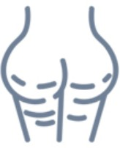

Cellulite
Cellulite and localized adiposity are imperfections that affect many women regardless of their age. These imperfections are characterized by slowing of the circulation system together with a lymphatic stasis that cause malfunctioning of all cellular activities, in particular those of adipose cells (which become hypertrophic). Numerous clinical studies show that SW therapy treatments reduce cellulite and localized adiposity, thus producing biological effects that promote vascularization, improvement of blood and lymphatic circulation, oxygenation of tissues, and activation of the metabolic processes responsible for cellular metabolism by encouraging and increasing lipase (a natural slimming mechanism).

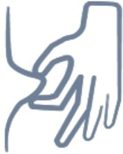

Body Shaping

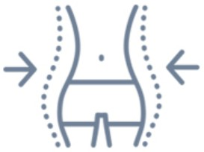

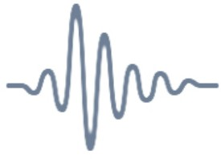
Skin Tightening
As time goes on, the skin begins to lose its normal elasticity and firmness. Often this problem manifests itself due to rapid slimming . Other factors such as excessive exposure to the sun, smoking and more generally a poor lifestyle may have an effect. soundwave therapy tightens skin by stimulating the production of fibroblasts, elastin fibres and collagen, increasing dermo-epidermal and connective tissue cohesion, thus the skin becomes more toned, compact, firmed and re-densified, and can be seen even after the first treatment session.
Treatment Areas: Upper Arms, Thighs and Skin Laxity

Soundwave therapy is widely used in aesthetics and surgery because of their ability to repair and regenerate tissue, promote blood and lymphatic circulation, normalize all physiological processes of the the body and skin, stimulate both deep (adipose and connective tissue) and superficial tissue (all layers of the skin). Soundwave therapy for body shaping can be used alone for the benefits stated above or is an excellent combination pre- treatment therapy to be paired with liposuction, or body contouring treatments as it prepares the skin to be more soft and fluid, thus avoiding any remaining anti-aesthetic accumulation or loss of elasticity in the skin. Treatment Areas: Abdomen, Love Handles and Saddle Bags

Stretch Marks & Scars

The skin is very important for our body and at the same time very delicate. Often, during the various stages of life: adolescent development, pregnancy and breastfeeding, hormonal changes, diets, intense sport activity, etc., the skin undergoes stress that causes the onset of scarring, and so called “streaks” more commonly known as stretch marks. Soundwave therapy can treat these imperfections, promoting a qualitative recovery of the skin and thus decreasing scarring and stretch marks over time. Soundwave therapy in this way works by stimulating the regenerative and reparative processes of tissues that take place throughout the structure of the skin

TREATMENT BENEFITS
- 100% NON-INVASIVE
- Quick Treatment With No Downtime
- Improves Skin Laxity and Firmness
- Suitable For All Skin Types
- Applicable Anywhere On The Body

